Data Analytics: The Impact of Text Preprocessing in News Articles

Sean Repti Miguel L. Ticzon  
Computer Studies and Engineering   
Jose Rizal University  
Mandaluyong, Philippines  
[seanreptimiguel.ticzon@my.jru.edu](mailto:seanreptimiguel.ticzon@my.jru.edu)

***Abstract*—Text preprocessing has been a necessary phase in the fast-growing data analysis field since it enables the transformation of unstructured text data into structured and machine-readable format. The paper puts emphasis on how text preprocessing affects news article analysis in an attempt to improve the precision and reliability of the data-driven insight. The paper inspects the applicability of the most famous preprocessing methods on different NLP applications, such as text classification, sentiment analysis, and trend identification. Among the preprocessing techniques are tokenization, stop word removal, stemming, lemmatization, etc. Our findings prove that the sequence and selection of preprocessing methods matter a lot for the way analytical models work and, therefore, for the quality of news obtained from the content analysis. It once again raises the awareness of careful re-evaluation of these preprocessing techniques in the context of modern data environments, more so in the light of the use of huge amounts of text data stemming from the media sector.**

***Keywords—Text preprocessing, Unstructured text data, Structured Data, Machine readable format, News articles analysis, Natural language processing, Text classification, Sentiment analysis, Trend identification, Tokenization, Stop word removal, Stemming, Lemmatization, Content analysis, Media, Media sector***

# Introduction

In the fast-changing technological environment, data analytics has been very critical in extracting information and patterns from raw data. Data analytics embodies a host of methodologies aimed at analyzing and comprehending complicated data sets that enable an organization to make informed decisions. Text preprocessing is a subset of data analytics aimed at cleaning and preparing text data for analysis. Basically, it involves the transformation of raw, unstructured texts into structured data. This step is imperative for the development of valid and relevant analyses since it standardizes and normalizes data in such a manner as to have the analytical procedures applied to it more suitably.

Text preprocessing is one of the initial phases in NLP and is quite an important stage in making an unstructured, irregular text into a machine-readable format [1]. Common techniques include tokenization, stop words deletion, stemming, and lemmatization [2]. These methods provide the backbone for many applications of NLP such as text classification, web search, and machine translation. Preprocessing procedures are both sequence and selection-dependent, therefore affecting output quality, hence necessarily corpus-and application-specific [2]. That is, it may change the original distribution of data, maybe affecting even metadata like type, location, and timestamps [3]. It will therefore be important for a researcher to have a critical assessment as to how preprocessing is going to affect their data and later analyses.

Text preparation still stands as the integral step in NLP, even with the rise of state-of-the-art pre-trained Transformers [4]. Its importance was recently somewhat underestimated in the value of literature, though studies have found that preprocessing can lead to significant effects on classification performance using both classical and state-of-the-art models [4]. Choice and ordering of preprocessing methods should be thought out and well-executed, as they may affect the performance of models on many NLP tasks [1]. In some cases, appropriate preprocessing allows simple models to work even better than Transformers [4]. However, preprocessing efficiency is data and task relative, and sometimes customized techniques are needed [2].

The trends and focal points in media coverage can be spotted using methods of NLP and text mining for the analysis of news content [5]. Applied text analytics solutions are able to unlock the value of text data across multiple industries [6]. Some kind of visualization techniques should be used with technologies like Event Registry API easing data collection and preparation. News trends could quickly be interpreted with the help of these graphic representations: word clouds, bar graphs, and line graphs. In light of this, the process typically involves data cleaning, removal of redundant attributes, application of several preprocessing techniques [8]. Taking all factors into consideration, these techniques give us insight into the news and its variations with respect to time.

These techniques find a huge number of applications in sentiment analysis, information extraction, and the detection of false news [9]. The text mining algorithms can identify how topics like big data have evolved over time by text analysis of news content and trends [5]. Organization data is largely unstructured at about 80%, and text analytics is key to transforming that data into meaningful business knowledge [10]. These are the technologies that support decision-making processes in finding patterns and relations from textual data to eventually improve resource allocation and maximizing advantages for different businesses [11].

Text preprocessing and data analytics are fundamental to navigating the complexities of modern data environments. Their application in news analysis highlights their importance in maintaining the integrity of information and ensuring the accuracy of insights derived from textual data.

# Review of Related Literature

Text preprocessing has a rich history in supporting different industries related to their workflow optimization. The section below, are some effects of text preparation in news and other important domains.

*1. Text Preprocessing in Healthcare*

Text preparation itself is important in the improvement of sentiment analysis in medical data and healthcare forecasting. [12]. demonstrated that text preparation processes improved the accuracy of sentiment analysis of health-related tweets by 5.4%. Another such study conducted by revealed that preprocessing techniques like multiple imputation and k-means for missing values and feature scaling improved the performance for machine learning models significantly while predicting Type II diabetes [13]. Deep learning techniques integrated with text processing have recently shown some promise for extracting clinical concepts, performing drug review sentiment analysis, and matching clinical trials [14].

However, existing algorithms are hard to apply to clinical areas due to the fact that such text data is complicated and multi-dimensional. In short, text preparation is paramount in increasing precision and efficiency in health predictions and analysis.

Text preprocessing in the medical domain is performed to bring out relevant data from clinical notes and electronic health records, improving patient care by facilitating the accurate diagnosis of diseases, suggesting treatment options, and predicting the patients' outcome.

*2. Text Preprocessing in Finance*

Financial institutions can make use of sentiment analysis from news items, client comments, and market trends in several ways through text preparation. This will help in detecting frauds, managing risk, and refining investment techniques.

Recent research in text preprocessing for finance highlights its importance in enhancing natural language processing (NLP) applications [15]. It demonstrated the effectiveness of combining NLP and machine learning for financial text categorization, achieving 94% accuracy with FinBERT [16]. Domain-specific preprocessing can significantly improve open information extraction tasks [17]. who reduced document data by 13% and enhanced relation extraction F1-score by 16% [16].

A provided comprehensive overview of NLP's evolution in finance, discussing challenges like data scarcity and adversarial examples [17]. To improve financial literacy, Ghosh and Naskar proposed NLP-based tools for enhancing the readability of financial texts, including neural-based readability assessment and hypernym extraction [18]. These studies collectively emphasize the crucial role of text preprocessing in finance, enabling more accurate analysis and improved comprehension of financial information.

*3. E-commerce Text Preprocessing*

Text preparation is imperative to sentiment analysis of e-commerce product reviews. Literature has revealed that proper preprocessing can enhance categorization accuracy significantly [19]. In general, it includes stemming and removal of stop words and blank spaces [20]. Scholars working on the effects of using various algorithms of stemming have reported that rule-based stemmers work better in increasing accuracy for the case of sentiment analysis in Indonesian commerce reviews [21].

Sentiment analysis has also benefited from deep machine learning methods, such as the CNN-BiLSTM model, which has been demonstrated to perform better on long texts [22]. Some of the classifiers that have been applied to the task at hand include the Support Vector Machine, Naïve Bayes, and Decision Tree; in some of such works, SVM has turned in quite high accuracy [19]. Most of these results tend towards a very important conclusion: appropriate text preparation is important to enhancing sentiment analysis in e-commerce applications.

*4. Social Media Text Preprocessing*

Since social media content is very noisy, word preparation becomes imperative. Processing stressed words and removing tokens with no letters works very effective in texts in Spanish [23]. In the case of Arabic social media text preprocessing, a four-step strategy has been outlined that encompasses data collection, cleaning, enrichment, and availability [24]. This would result in a structured dataset with a number of attributes that can be used in future research. Preprocessing methods have been demonstrated to improve the accuracy of prediction for early depression detection; more importantly, mapping emoticons into real emotion words is one of the key steps toward balancing the evaluation measures [25].

According to the studies, preprocessing is necessary in view of improving the quality of the text data from social media for many various applications—emotion classification, topic categorization, sentiment analysis, and mental health monitoring. The exact nature of preparation tasks may differ based on the language and on the purpose of the analysis to be conducted. The specific preprocessing tasks may vary depending on the language and intended analysis.

*5. Legal Domain Text Preprocessing*

Recent work in legal text processing has focused on various techniques for interpreting and retrieving data from complex legal documents. Deep learning, knowledge-based processing, and natural language processing have all been studied for the analysis of legal documents [26]. To facilitate the analysis of Spanish legal content, such as Legal-ES, extensive resources have been produced, such as word embeddings, topic models, and corpora [27].

Topic modeling with domain-specific embeddings, like LEGAL-BERT, has shown promise in the identification of semantic structures in legal texts [28]. Several propositions have been made to deal with the challenge of limited training data by utilizing domain expertise at the stage of generating annotated data to enable automatic segmentation of legal texts [29]. These developments are intended to improve information retrieval, document comprehension, and processing efficiency in the legal arena, thus benefiting both legal professionals and the general public.

# Methodology

*1. Data Collection*

The dataset to be used in collecting this study's data is obtained from Kaggle and deals with fake news classification. The dataset is offered in CSV format and the name of the dataset is ‘Fake_Real_News_Data.csv’. Since this data set contains a wide variety of news articles, from the accurate to misleading report, it is going to offer an in-depth exploration of the text preprocessing techniques in the context of fake news detection. The dataset contains a number of elements such as headlines, and article content.



1. Shows the source of the dataset in kaggle.

*2. Dataset Attributes*

The dataset consists of unclean and unnormalized raw data. It contains several attributes related to text analysis, which are needed during preprocessing. Some key features in the dataset include:

1. ‘#’: The ID of the news item. This unique identifier allows tracking and reference to singular records in the dataset.
2. **‘title’**: The news title or headline. This property conveys a quick glance at the content and often includes some of the target keywords that would be useful for initial filtering or analysis.
3. **‘text’**: The primary body of the news is represented by text. This is likely to be the main source of data for text analysis and will involve a significant amount of preprocessing in order to clean and normalize.
4. **‘label’**: Classified label for whether the news is fake or not. This attribute is important in supervised learning tasks since it is through this that a model trains and gets evaluated.

These are the columns that are present in the dataset, mainly the ‘text’ column is one that needs to undergo in text preprocessing.

In text preprocessing the data amount, rows, columns, and words are important. The number of total data points presents the size of a dataset and shows the amount of processing that is to be done. Rows show the total of news stories, while columns represent the properties of each record. This dataset contains four columns: # (id), title, text, and label. More specifically, it gives the number of words in each column with text, so one can get an idea about the volume of text data. A column with missing values has to be identified, and the number of missing values has to be quantified since missing values may alter the accuracy of the analysis. Proper handling of missing values in a dataset

is essential for maintaining the integrity of the dataset and producing relevant results.

First import all the relevant libraries, including pandas, and drive from google.colab. Then mount our Google Drive, so contents there can be accessed; it allows reading and writing data straight from the drive. This is followed by the importing of our dataset into a DataFrame and any kind of preparation necessary to have the data ready for modeling and more investigation.

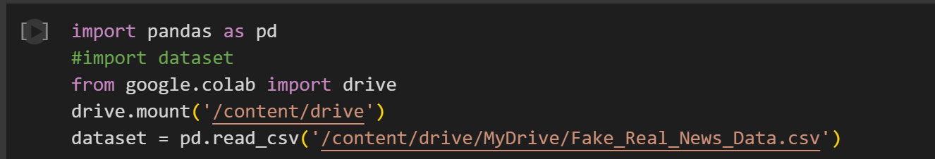

1. Shows a block of code containing the necessary libraries for checking and for text preprocessing.

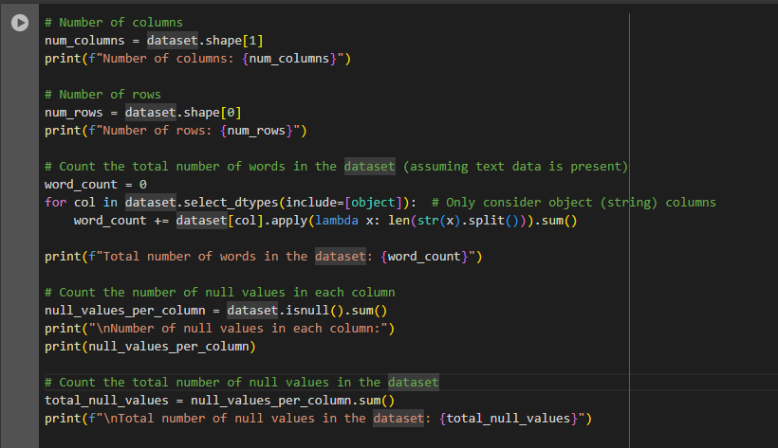

1. Shows a script on how to get the total number of columns, rows, word count and null values.

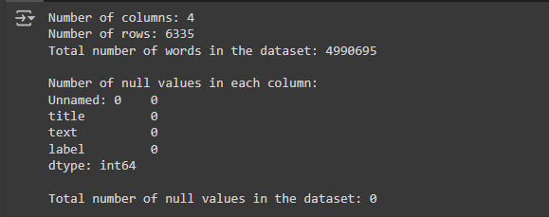

1. Shows the output of the script on Fig. 3.

This dataset has 6,335 rows and 4 columns, with a total of 4,990,695 words in all text entries. The following are columns in this dataset: #(id), title, text, and label. The counts in each column show no null values in each column. There are no null values overall; thus, the dataset is complete and ready for analysis. The large scale of the dataset makes it contain a considerable amount of textual data, which will efficiently work out during text preparation and further analysis.

*3. Text Preprocessing*

Text preprocessing is therefore an important step in the analysis and modeling of raw text data. Some of the important techniques used in this process are lowercasing, which makes sure that all text is in lowercase and thus in a uniform format; special character removal, to get rid of non-alphanumeric characters and concentrate on meaningful content; removal of stopwords, which filters out very common but relatively unimportant words so as to reduce noise; and tokenization, separating text into words or phrases so additional analyses can be done on it. It is through these preparation procedures that data gets streamlined, the quality improved, and optimized for use in further text analysis and machine learning activities.

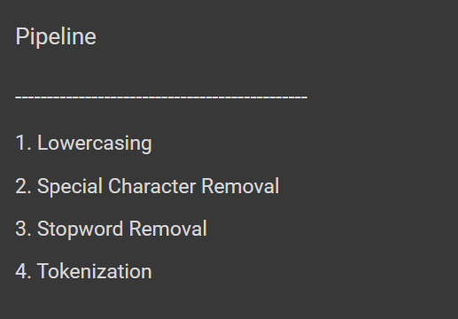

1. Pipeline and the text preprocessing techniques

The Examples of noise in the dataset are missing punctuation, misplaced quote marks, dashes, and other extraneous elements, such as URLs and email addresses: 'https://t.co/VyTT49YvoE pic.twitter.com/wCvSCg4a5I' and 'undergroundreporter2016@gmail.com'. Such components add up to a lot of clutter, which might actually impede the analysis.



1. Shows the dataset URL noise

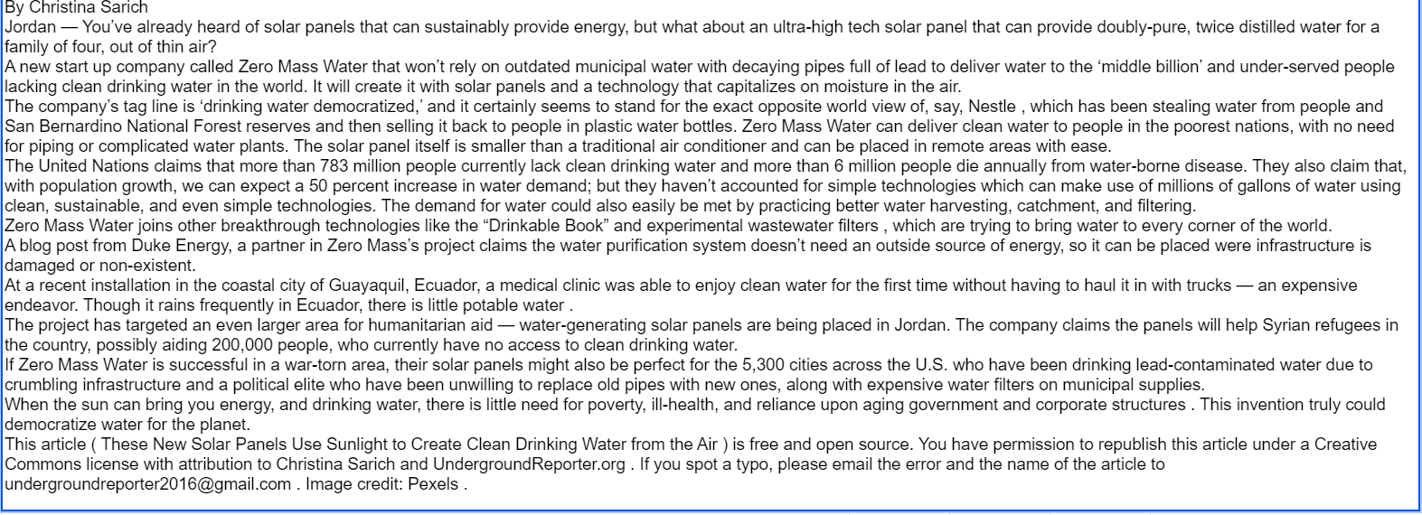

1. Shows the dataset email address noise

**Lowercasing**

Lower casing is a preprocessing technique that transforms all the characters in a text into lower case. Removal of case sensitivity is a critical step when carrying out textual data analysis since it ensures homogeneity. This makes a text consistent in a single case.



1. Show a code that will view the first row of the dataset.

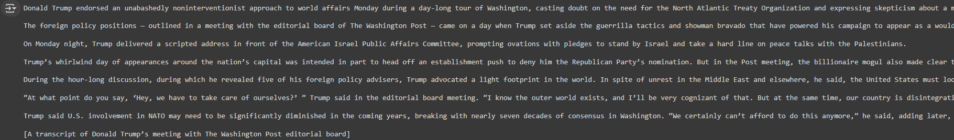

1. Shows the output of Fig. 8. which is the first row of the dataset.

It is important to look at some example data in the dataset, just to see what it looked like before lowercasing it. This step outlines how the text is formatted and if there are any case variations.

The next line is ensuring all words are in lowercase by applying a lowercasing technique on the sample data of the dataset. This removes capitalization-related variations and therefore maintains consistency to increase the accuracy of text analysis.

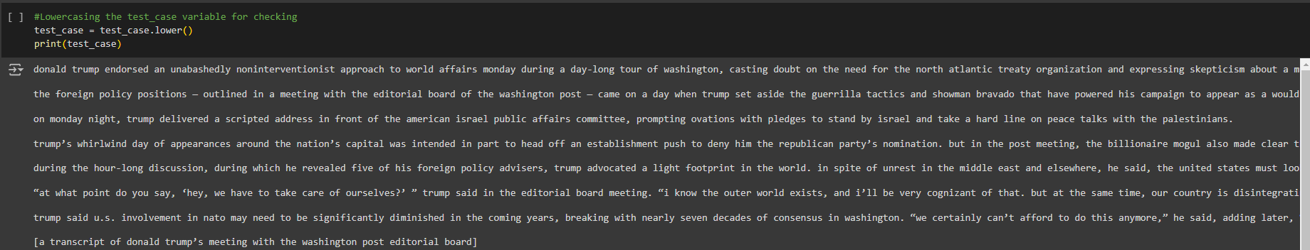

1. Applying lowercasing on sample data.

After applying the lowercasing technique in the sample data in the dataset. Now apply the whole lowercasing technique in the dataset, specifically the ‘text’ column where in it contains text data.

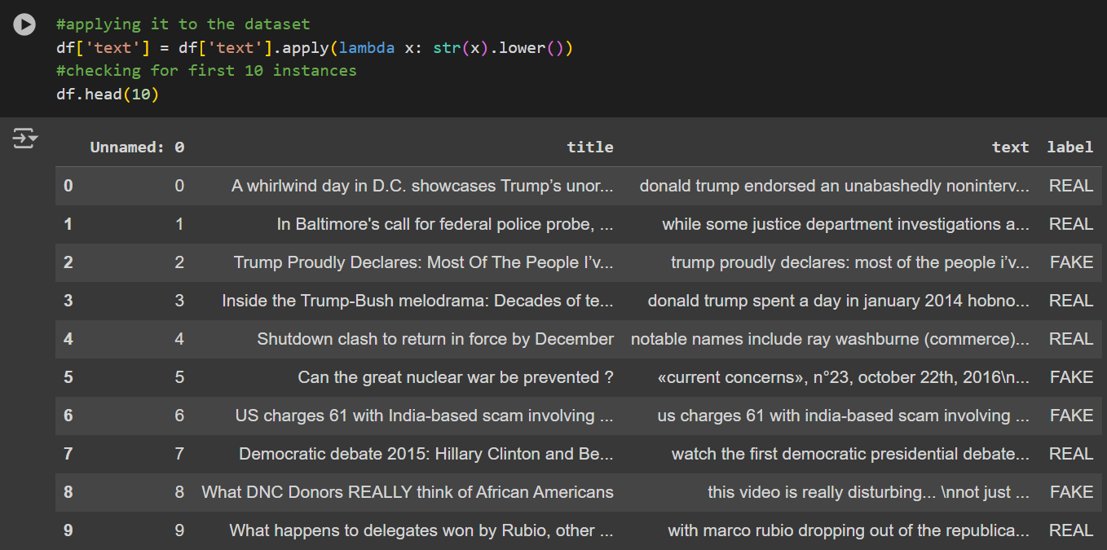

1. Applying the whole lowercasing technique.

**Special Character Removal**

Special character removal is one of the methods in preprocessing with the objective of cleaning up the textual data by erasing all non-alphanumeric characters, including whitespace characters, symbols, and punctuation. This reduces background noise and other possible distractors so that you focus on the significant material in your text. Eliminating these characters will render the dataset more homogeneous, readable, and thus improve the effectiveness of later text processing operations.

Importing the required libraries is a must before removing any special characters from the dataset. The re package, which supports regular expressions in Python, will be utilized for this operation in order to locate and eliminate any special characters from the text.

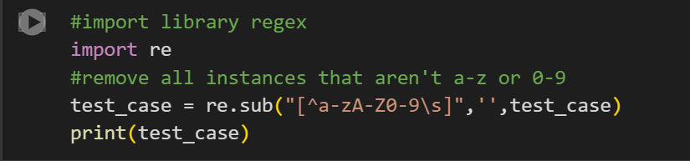

1. Importing the package for removing special characters.

Now, apply the imported libraries to the dataset. This will involve removal of special characters from the text data using the 're' library so that the dataset is clean and ready to proceed to further stages for processing.

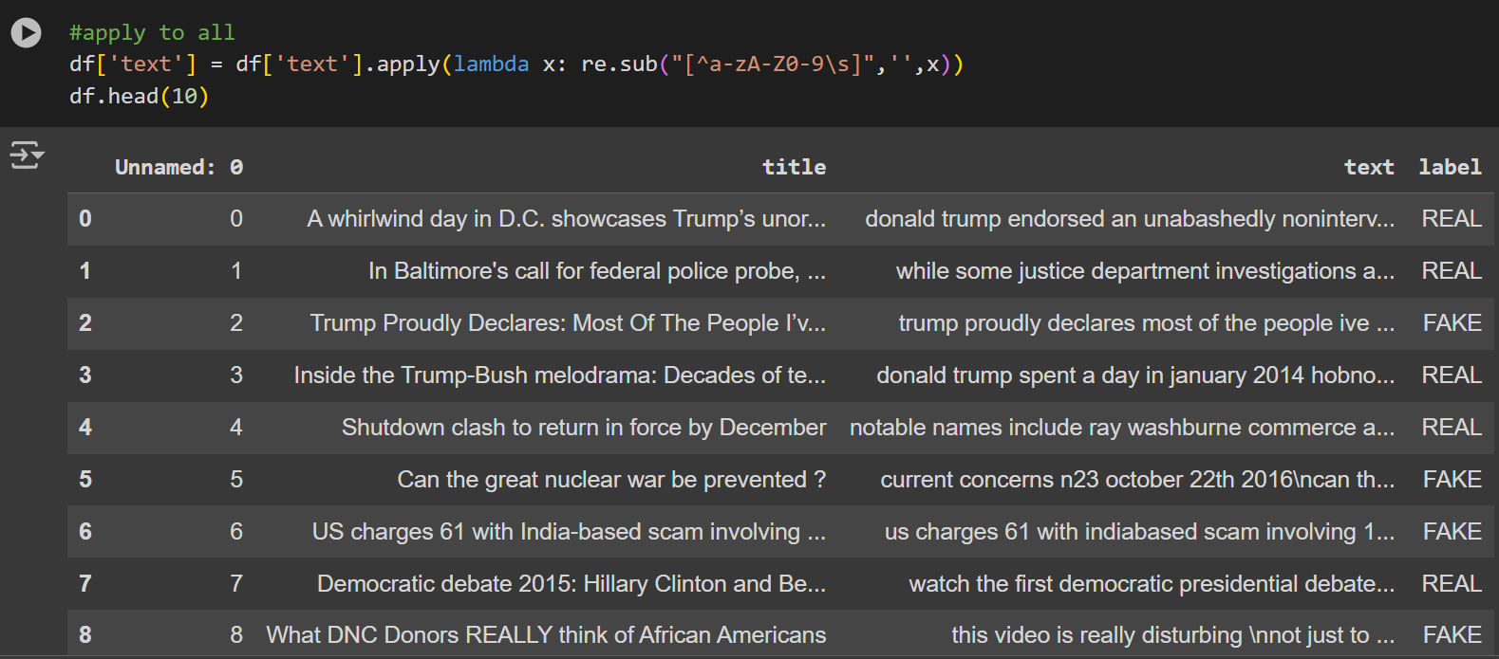

1. Applying the special character removal technique in the dataset.

For more inspection of the application of the special character removal. Getting a sample line in the dataset can validate whether the technique is applied correctly

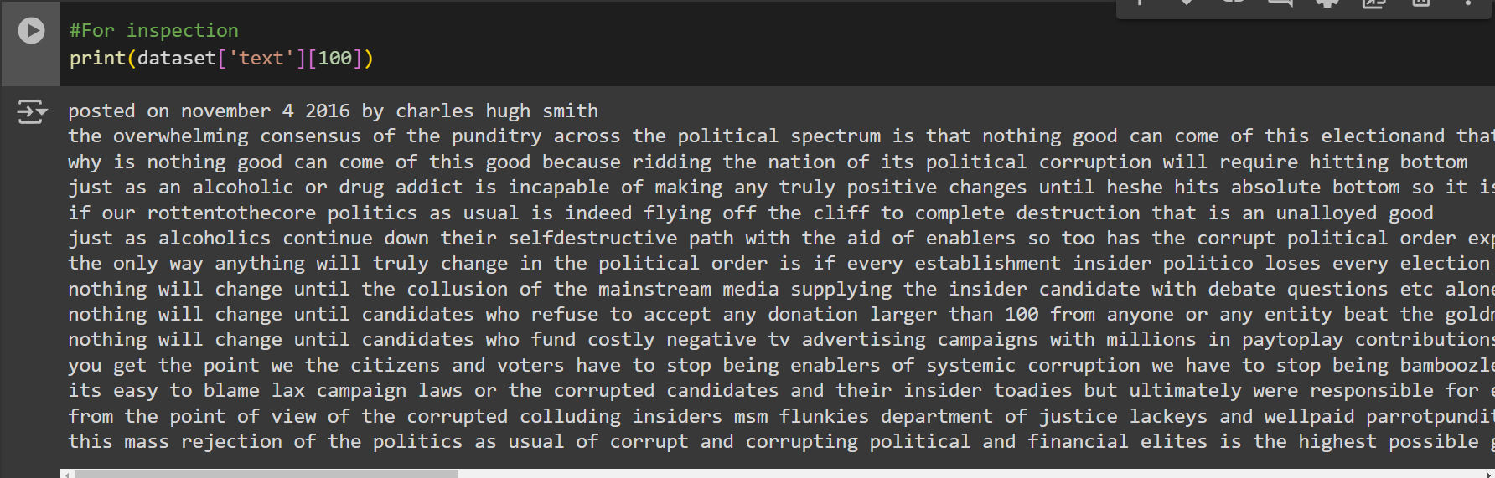

1. Shows the index 100 data in the dataset.

**Stop Word Removal**

In text preprocessing, stop word removal is one of the important stages; it removes common terminologies like "and," "the," "is," and "in" out of the dataset. These words are generally known as "stop words," which, on general grounds, are less pertinent in meaning and may confuse the study. By their elimination, can bring into sharper focus the important words that contribute towards the overall setting of the text. This process helps in the effective betterment of tasks such as sentiment analysis, topic modeling, and text classification.

The list of the English stop words has to be imported by download from the NLTK package and then set up for removal. The following procedures can be done in order to achieve that:

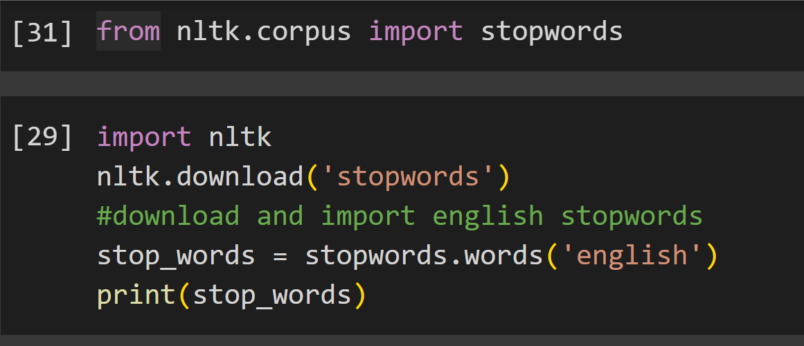

1. Code snippet of importing important libraries.

The following code downloads the 'stopwords' corpus, which contains a large list of common English stop words, from the NLTK library. The actual stop words can then be accessed by loading them into a variable after the download

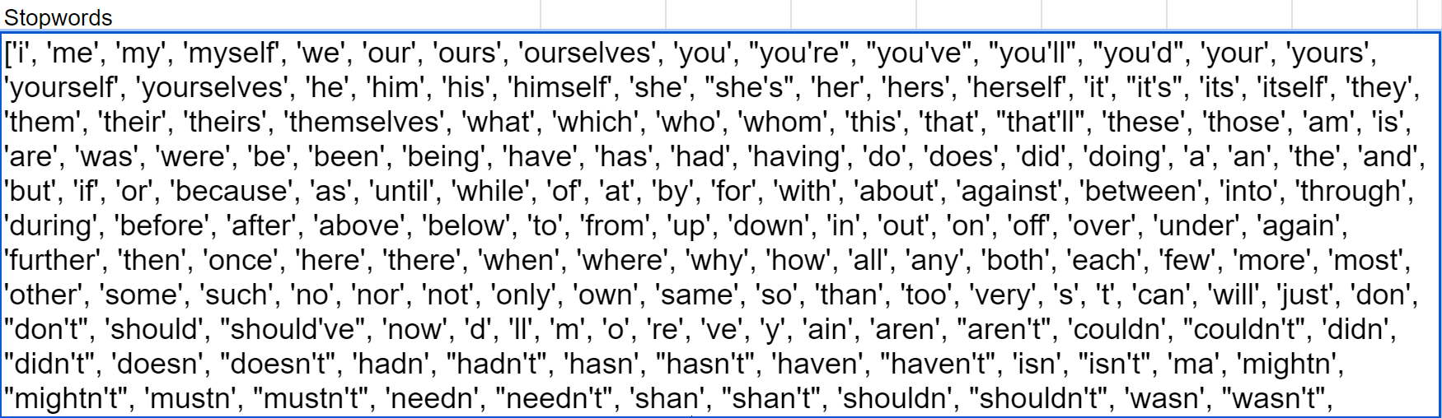

1. The list of stop words listed in the NLTK package.

As shown in Fig. 16. The NLTK package provides a range of stop words in English usage. Those are conjunctions, prepositions, article words, and others which are normally not very useful to text analysis. The stop word list from NLTK is used in cleaning and preprocessing text data in NLP projects for the removal of such high-frequency terms but low value so that focus remains on the more useful information in the text.

Before applying the stop words removal technique to the ‘text’ column, It will be tested on the first row of the dataset.

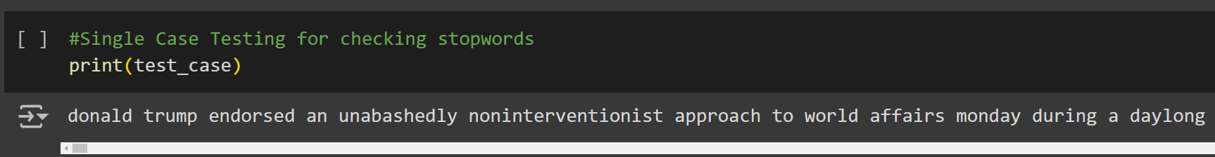

1. Code snippet for viewing the first row of the dataset.

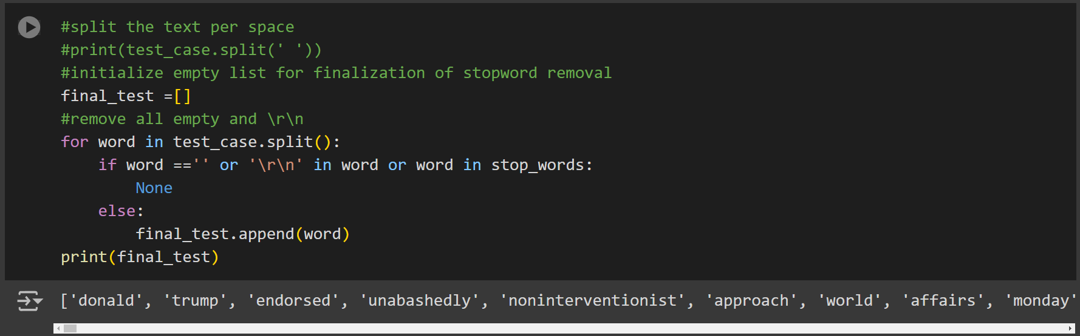

1. Code snippet of applying the removal of stop words.

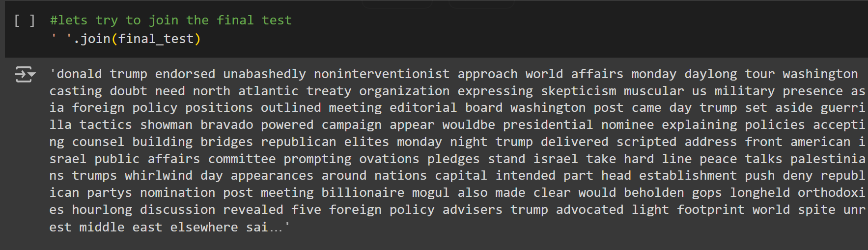

1. Joining all of the words together.

Fig. 19. shows that, after performing stop word removal on the first row of the dataset, the text has become clearer and much more concise for the machine to understand the text better.

Now that stop word removal is successfully applied to the first row of the dataset, apply it to the entire column of text in the dataset.

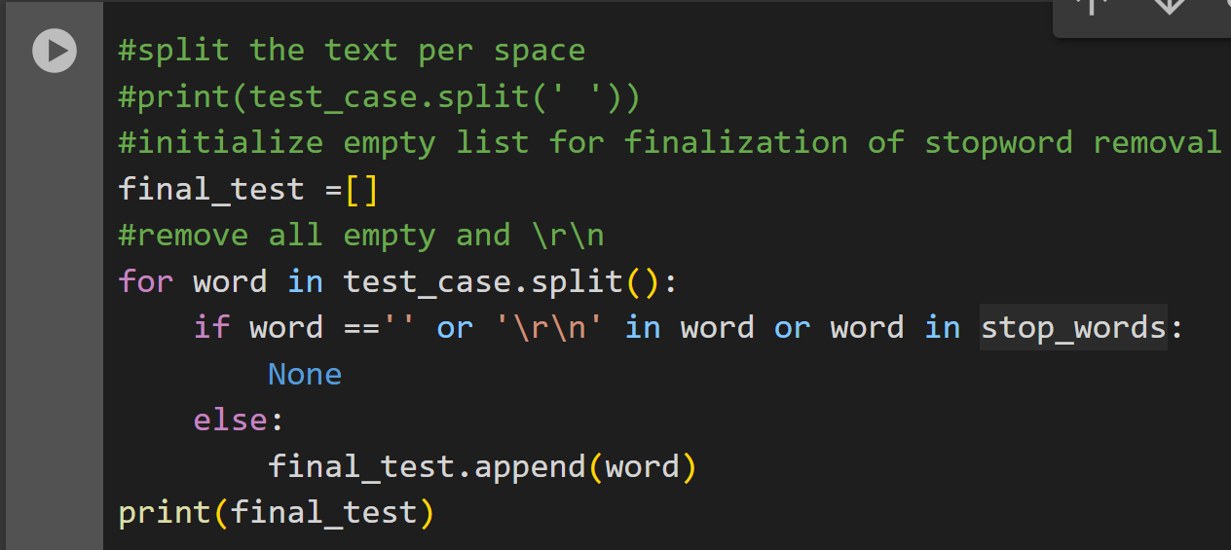

1. Applying the stop word removal technique on the dataset

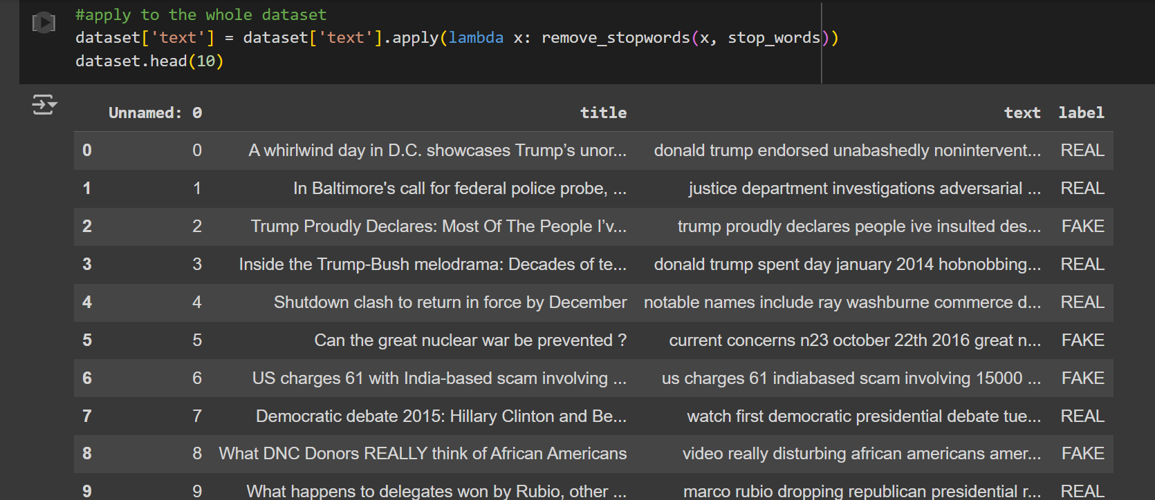

1. Showing the whole dataset and the application of the stop words removal

**Tokenization**

One of the ways of text preparation is tokenization, which is the process of breaking a text into smaller parts called tokens. Depending on the level of detail required, tokens could be in the form of words, sentences, or even symbols. Conversion of text to token makes text analysis and processing easier; therefore, doing jobs such as Sentiment Analysis, Language Modeling, and Text Classification becomes easier. Tokenization streamlines the structure of the text, hence making them easier to handle and more suited for in-depth examination.

Before carrying out tokenization, it is essential to import the necessary libraries. We will be using the NLTK library, which has high capacity in the area of text processing for this assignment. Run the following code to import NLTK, then download the 'punkt' tokenizer models:

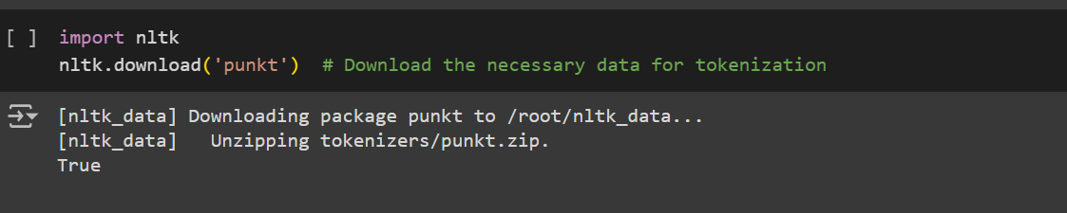

1. Importing nltk and download punkt

It makes use of the 'punkt' tokenizer models to split text into tokens correctly. After downloading the models, you are ready to apply tokenization to your dataset efficiently just by importing the libraries.

Now that you have imported NLTK and downloaded the 'punkt tokenizer models, you should use the word_tokenize function from the nltk.tokenize module. Execute the word_tokenize function using the following implementation code:

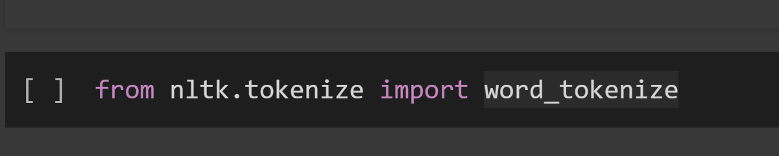

1. Importing word_tokenize

You can transform your text input into a list of tokens by running word tokenize over it. This will make extra analysis and processing easier.

Now that the word tokenize function has been created and the required libraries have been loaded, it is time to apply the tokenization technique on the dataset. Use the function word_tokenize to take the text apart and convert it into individual tokens in the `text` field. It is turning each piece of text into a list or chain of words or tokens. This process makes it easy to work with data and analyze each set of the results. The commands below show how to tokenize the entire set of records:

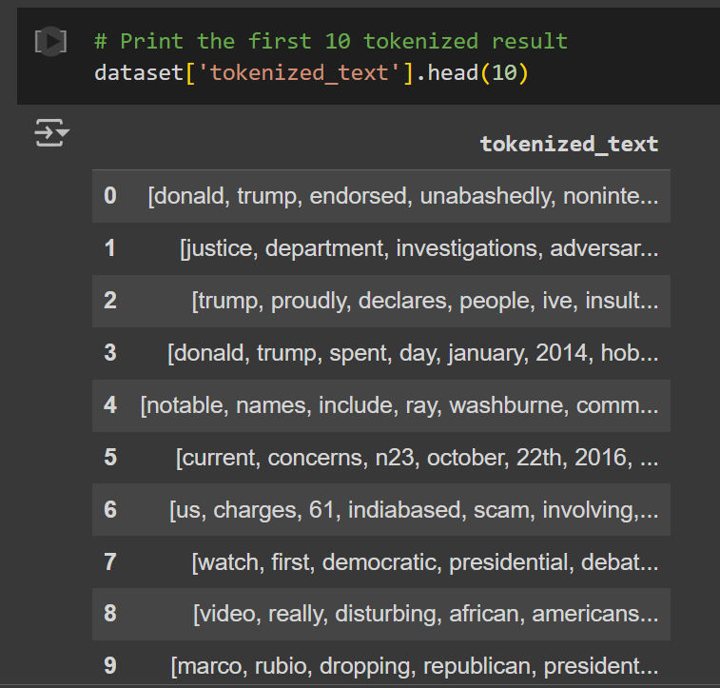

1. Applying the tokenize technique to the ‘text’ column dataset

The dataset will be tokenize every entry in the column 'text' and then store these generated tokens in another column called 'tokens'. Validating the results ensures that tokenization has been applied correctly throughout the dataset.

# Results

We will discuss the results of applying various text preparation methods to the dataset in this section. The obtained results will include how the text data is refined by lowercasing, removal of special characters, stop words, and tokenization, among other preprocessing techniques. Detailed information on the pre-processing steps is presented below, which includes lowercasing, tokenization, stop word removal, and special character removal.

**Lowercasing**

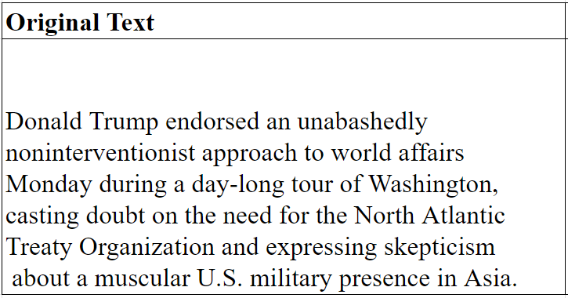

1. Original text from dataset

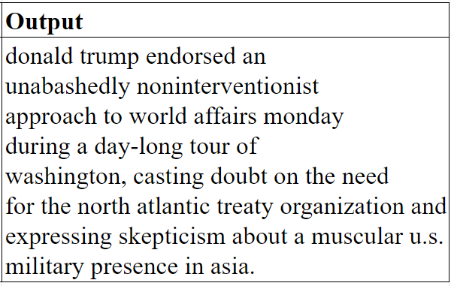

1. Text preprocessed using lowercasing

This is a method that changes all characters to lowercase, from the corresponding uppercase letters that were present in the content of the dataset obtained using the lowercasing method. The number of unique words decreased slightly, indicating that some words were consolidated

**Special Character Removal**

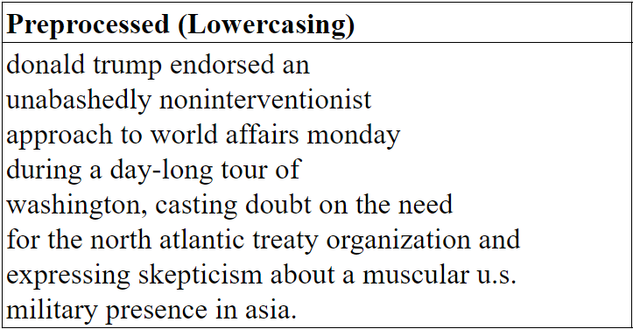

1. Text preprocessed using lowercasing

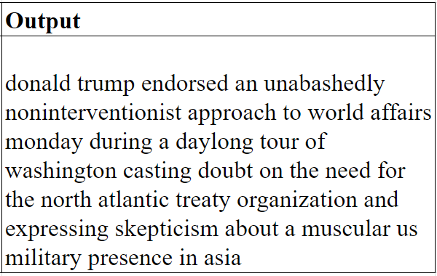

1. Text preprocessed using lowercasing and special characters removal.

Before special character removal, the dataset contained various symbols and punctuation, such as the period(.), comma (,) and dash (-). and special characters. These characters can introduce noise and variability into the text, which may hinder the effectiveness of text analysis algorithms. The removed special characters most of which were symbols and punctuation, created cleaner text data.

**Stop Word Removal**

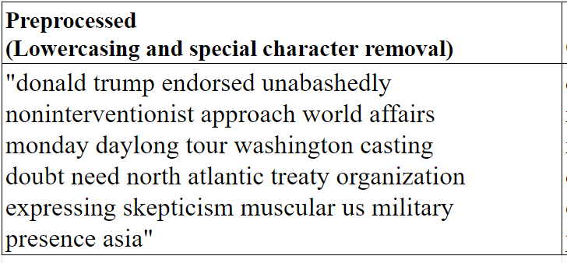

1. Preprocessed using lowercasing and special character removal

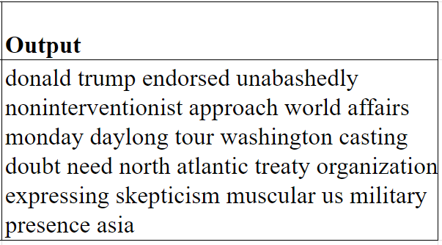

1. Text processed using stop word removal

Before stop words removal, the dataset includes common words such as "the," "and," "is," "in," and "to," which appear frequently but contribute little to the meaning of the text. These stop words can add unnecessary noise to the dataset and may dilute the impact of more meaningful words during analysis. The overall word count of the text dropped after removing the stopwords, which reduced its content to more important themes.

**Tokenization**

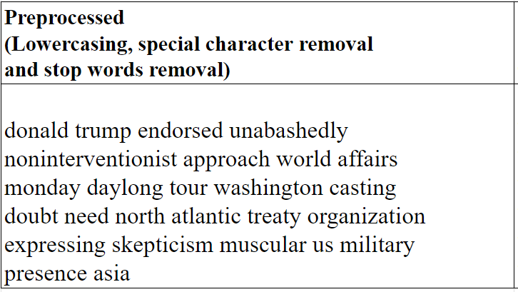

1. Text processed using lowercasing, special character removal and stop words removal.

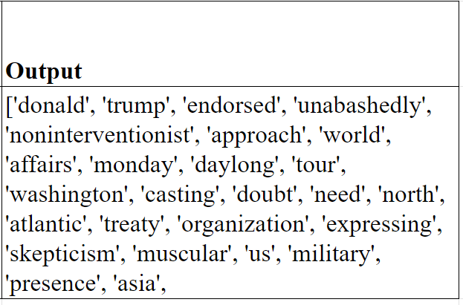

1. Text processed using tokenization

tokenization involves dividing the text into independent units for analysis; these are usually words or phrases known as tokens. The text had been tokenized well, so further processing and analysis were possible.

Lowercasing, removal of special characters, removal of stop words, and tokenization are all applied to get the result of a substantially cleaned and standardized dataset. Now all characters are in lower case, with no unimportant symbols or special characters and common stop words removed, so there's a much more standard form for the text. Every document becomes a list of distinct tokens standing in for the main ideas in the text.

This text preprocessing thus makes the dataset more appropriate for study and guarantees that the data is free of noise and irregularities. The efficacy of text mining and machine learning algorithms is increased since the generated text will be concentrated on significant words and phrases. It enhances models for the detection of fake news through the preparation of data in a way that will let models work on cleaner information relevant in some respect. As such, this preparation pipeline is therefore a requirement for bringing forth reliable and insightful outcomes relative to text analysis.

# Discussion

We now delve into the implications of the text preprocessing methods we adopted for our dataset and how, in totality, they impact the value of the analyses toward the detection of fake news. In addition, we have done lowercasing, special character removal, stop-word removal, and tokenization, which has changed this dataset significantly, making it better and increasing its utility and quality of being a guide for any future analytics work.

**Lowercasing**

Lowercasing will help in standardizing the content in the end by changing all characters into lowercase. This way, the irregularities that result from different cases are removed to ensure that words are consistently represented. Lowercasing ensures that analysis algorithms find and analyze identical words regardless of their original case, hence the problem of case sensitivity is handled to improve the accuracy of text matching and comparison. Such uniformity in representation will reduce ambiguity and ensure that text analysis activities, such as sentiment analysis or fake news detection, are founded on a homogeneous and reliable dataset.

Additionally, it enhances the efficiency of latter text processing by making the text data simple. Once the text is in a uniform format, other preprocessing activities of the text with respect to tokenization and feature extraction become easy to understand and implement. The end result is more accurate and significant text analysis since consistency cuts down on errors or discrepancies that may be a result of case variations. Therefore, the lowercasing technique is basic to increasing the quality of the dataset as a whole and making text data ready for advanced analysis.

**Special Character Removal**

Another very important preprocessing step is the removal of symbols and punctuation marks that are introduced to deal with the likely increase in noise or variability within text data. Special characters should be removed from the dataset, as they are most likely to lead to malfunctioning in most text analysis algorithms. Such characters may include dashes, commas, periods, and exclamation marks. This helps lower the possible complexities and reduces the likelihood of eventual distortion in data. Cleaning of the data is necessary to eliminate such unwanted distortions of symbols on the text analysis and focus essentially on the material at hand. Deletion of special characters further reduces the text to lower-level attributes, which can be easy for algorithms to recognize and process linkage and relations of meaning.

Removal of special characters furthermore ensures improved consistency and quality of the dataset. The text data is cleaned, enhancing it for algorithms sensitive to non alphanumeric characters.

This step in preprocessing aids in improving classification models and is relevant to the highest standards in the analysis of texts. Special characters can cause uneven tokenization and feature extraction in most applications of text analysis, especially sentiment analysis and fake news detection. For instance, punctuation might get treated as different tokens or impact the sentiment scores for the text. Normalizing the language in order to rid it of these characters ensures that the next analysis is predicated on a more pristine and consistent dataset. By focusing on the most integral information in the text, this preprocessing step thus helps raise the accuracy of text processing tasks and tends to produce results that are more dependable and perceptive.

**Stop Word Removal**

Among the fundamental preprocessing techniques that would be able to address problems with issues of the high recurrence rate of words, yet semantically irrelevant in a text, is removing stop words. Examples of common stop words in many texts include "the," "and," "is," and "in," which alone do not add much more meaning to a text. They can probably add noise and dilute the strength of more meaningful words. We simplify the text and focus the analysis on the terms that convey important information by removing such stop words. In this process, other than reducing the dimensionality of the data set to a minimum, important themes or topics in the text will be highlighted. This makes it easier to conduct the later analysis tasks such as sentiment analysis or topic modeling.

This will make the machine learning algorithms applied in the fake news detection more efficient by removing stop words. By successfully decreasing the text data complexity and increasing the signal-to-noise ratio by removing the stop words.

This step is very important in enhancing the performance of the algorithm of text categorization, since it lets models give more focus to terms that are more important.These will only fill the feature space with irrelevant information that may lead to inefficiency and even failure of the analysis. We reduce this corpus based on meaningful content, in turn directing the algorithms to focus on important terms and phrases more likely to distinguish between true and fake news. This will help in improving the precision of the detection algorithms and also enhance the ability to identify minute clues and irregularities linked with bogus news. In simple words, stop word removal cleans the dataset, making it more analyzable and relevant. This would form the bedrock of any reliable and robust fake news detection algorithm.

**Tokenization**

One of the ways for preprocessing is tokenization, which divides text into distinct parts called tokens. It is in this way that content not structured can be transformed into structured and more in-depth scrutiny-friendly content. In this way, tokenization will allow the extracting of single textual elements, something very essential to a myriad of text analysis applications. This will then give us an opportunity to treat each component within the text in a systematic way after tokenization for processing and analysis, which would support more accurate feature extraction and pattern recognition.

Tokenization is necessary to enhance the efficiency of detection algorithms with respect to the identification of bogus news. Tokenization makes unstructured text easier to convert into a format which can be more readily handled and evaluated. Indeed, it forms a step that is actually required as a prerequisite for many techniques of text analysis, improving the whole effectiveness of the process of categorization.

The technique makes it possible to identify specific words and phrases that may give a clue of the deceptive content and analyze them effectively by breaking down the text into tokens. Granularity allows the software to recognize linguistic minutiae, irregularities, and contextual cues indicative of fake news.

For example, tokenization may be able to identify critical terms or phrases in wording that seldom appear in real news stories but are quite common in bogus ones. This is fairly a focused method of enhancing the model's discriminant features between authentic and fraudulent news items and hence rendering more reliable and effective detection results. It is, therefore, an indispensable process in the preparation of text data for analysis, making sure that relevant textual components could be recognized and categorized for news items by the detection system.

# Conclusion

The study has emphasized the need for text preprocessing approaches for quality improvement and quality text analysis in news stories. Text preprocessing refers to cleaning text data in preparation for accurate analysis. Common methods under text preprocessing include tokenization, removal of special characters, removal of stop words, and lower casing. All these techniques thus contribute to cleaning and normalizing a dataset so that the analysis being done will have a proper ground based on valid and relevant information.

**Main Findings**

1. **Lowercasing**: Combining variants, standardizing the text to lowercase, has increased uniformity and reduced the number of unique terms. This step provided clarity in understanding the dataset, making it ready for further research by reducing redundancy.
2. **Special Characters Removal**: The removal of non-alphanumeric characters resulted in cleaner text data. Noise reduction, which resulted in a more focused dataset, is quite important in reliable text classification.
3. **Stop Word Removal**: Focusing on more important terms, the complexity of the dataset was therefore reduced by removing common stop words. This step improved the performance of the classification models with an increased signal-to-noise ratio.
4. **Tokenization**: This phase of text division into discrete tokens made structured format available and ready to use for many different textual analysis techniques. The preprocessing step basically established the ground for further investigation and model training.

**Implications of Findings**

The quality and organization of the text data would be greatly improved because of such preprocessing techniques applied within this research. Cleaning, standardization, and organization of the text make its classification more precise and effective. The results demonstrated that careful preprocessing of the text is very important in providing the extraction of reliable and valuable information from text data.

**Importance of the Study**

Preprocessing strategies are essential to improve the performance of classification models, ensuring the required classification and analysis results are given. Therefore, the study proves the fact that pre-processing is imperative when conducting any form of text analysis or classification.

**Potential Applications and Extensions**

Such improvements in the text data have advantages in information retrieval, fake news detection, sentiment analysis, and many more. It may be interesting for further research to augment preparation methods or adjust their combination to achieve even better quality in data and efficiency in the model.

**Directions for Future Research**

1. **Advanced Preprocessing techniques**: Text data preparation can be developed using techniques for advanced tokenization, stemming, or lemmatization.
2. **Model Performance Analysis**: Through modeling of the performance of different classification techniques, one can easily differentiate it by checking the implementation of different preprocessing stages in the performance of these techniques.
3. **Application to Other Fields**: It generalizes the preprocessing approaches over several datasets and across various domains that may prove applicability in diverse applications and scenarios.

The study concludes that good text preprocessing is essential for good performance on text categorization tasks. It is further to be understood that with the application and betterment of these methodologies, scholars and professionals can increase the precision and reliability of text-oriented evaluations even more.

##### Acknowledgment

Thanks to our professor, Dr. Rodolfo Raga, for their invaluable guidance and support throughout this project. I also acknowledge the dataset from Kaggle, which played a crucial role in my research. Finally, I would like to express my personal gratitude to myself for contributing to the success of this work.

##### References

1. N. M. A. Rajesh and N. D. T. Hiwarkar, “Exploring Preprocessing Techniques for Natural Language Text: A Comprehensive Study using Python Code,” International Journal of Engineering Technology and Management Sciences, vol. 7, no. 5, pp. 390–399, Jan. 2023, doi: 10.46647/ijetms.2023.v07i05.047.
2. C. P. Chai, “Comparison of text preprocessing methods,” Natural Language Engineering, vol. 29, no. 3, pp. 509–553, Jun. 2022, doi: 10.1017/s1351324922000213.
3. V. A. Kozhevnikov and E. S. Pankratova, “Research of Text Pre-Processing Methods for Preparing Data in Russian for Machine Learning,” Theoretical & Applied Science, vol. 84, no. 04, pp. 313–320, Apr. 2020, doi: 10.15863/tas.2020.04.84.55.
4. M. Siino, I. Tinnirello, and M. La Cascia, “Is text preprocessing still worth the time? A comparative survey on the influence of popular preprocessing methods on Transformers and traditional classifiers,” Information Systems, vol. 121, p. 102342, Mar. 2024, doi: 10.1016/j.is.2023.102342.
5. M. Haider and A. Gandomi, “When big data made the headlines: mining the text of big data coverage in the news media,” International Journal of Services Technology and Management, vol. 27, no. 1/2, p. 23, Jan. 2021, doi: 10.1504/ijstm.2021.113574.
6. R. Shanmugam, “Practical text analytics: maximizing the value of text data,” Journal of Statistical Computation and Simulation, vol. 90, no. 7, p. 1346, Jun. 2019, doi: 10.1080/00949655.2019.1628899.
7. K. Doshi, S. Gokhale, H. Mamtora and P. Bide, "Analytics and Visualization of Trends in News Articles," 2019 International Conference on Advances in Computing, Communication and Control (ICAC3), Mumbai, India, 2019, pp. 1-9, doi: 10.1109/ICAC347590.2019.9036812. keywords: {Market research;Bars;Sports;Data visualization;Twitter;Education;News trends;Data visualization;Analysis;Variation;Graphs;Charts;Category;News articles},
8. A. Kulkarni and A. Shivananda, “Exploring and processing text data,” in Apress eBooks, 2019, pp. 37–65. doi: 10.1007/978-1-4842-4267-4_2.
9. Y. Liu, “Natural language processing in data Analytics,” in Auerbach Publications eBooks, 2020, pp. 117–132. doi: 10.1201/9781003019855-7.
10. N. M. Ranjan and R. S. Prasad, “Text Analytics: an application of text mining,” Journal of Data Mining and Management, vol. 6, no. 3, pp. 1–6, Nov. 2021, doi: 10.46610/jodmm.2021.v06i03.001.
11. J. Kolluri, S. Razia, and S. R. Nayak, “Text classification using machine learning and deep learning models,” SSRN Electronic Journal, Jan. 2020, doi: 10.2139/ssrn.3618895.
12. Kumar, C. S. P., & Babu, L. D. D. (2018). Novel Text Preprocessing Framework for Sentiment Analysis. In Smart innovation, systems and technologies (pp. 309–317). https://doi.org/10.1007/978-981-13-1927-3_33
13. Misra, P., & Yadav, A. S. (2019b). Impact of preprocessing methods on healthcare predictions. SSRN Electronic Journal. <https://doi.org/10.2139/ssrn.3349586>
14. Rani, S., & Jain, A. (2023b). Optimizing healthcare system by amalgamation of text processing and deep learning: a systematic review. Multimedia Tools and Applications, 83(1), 279–303. <https://doi.org/10.1007/s11042-023-15539-y>
15. M. S. Alias, M. H. Fuad, X. L. Hoong, and E. G. Hin, "Financial Text Categorisation with FinBERT on Key Audit Matters," in 2023 IEEE Symposium on Computers & Informatics (ISCI), 2023, pp. 63-69.
16. C. Prakash, P. K. Chittimalli, and R. Naik, "Domain Specific Text Preprocessing for Open Information Extraction," in Proceedings of the 15th Innovations in Software Engineering Conference, 2022.
17. A. W. Lo and M. Singh, “From ELIZA to ChatGPT: The evolution of Natural Language processing and Financial Applications,” The Journal of Portfolio Management, vol. 49, no. 7, pp. 201–235, Jun. 2023, doi: 10.3905/jpm.2023.1.512.
18. S. Ghosh and S. K. Naskar, "Using Natural Language Processing to Enhance Understandability of Financial Texts," in Proceedings of the 6th Joint International Conference on Data Science & Management of Data (10th ACM IKDD CODS and 28th COMAD), 2023.
19. M. Arief and M. B. Deris, "Text Preprocessing Impact for Sentiment Classification in Product Review," 2021 Sixth International Conference on Informatics and Computing (ICIC), pp. 1-7, 2021.
20. Y. F. Faidha, G. F. Shidik, and A. Z. Fanani, “Study Comparison Stemmer to optimize text preprocessing in sentiment analysis Indonesian E-Commerce reviews,” 2021 International Conference on Data Analytics for Business and Industry (ICDABI), Oct. 2021, doi: 10.1109/icdabi53623.2021.9655867.
21. N. Ramshankar and J. P. PM, “Automated sentimental analysis using heuristic-based CNN-BiLSTM for E-commerce dataset,” Data & Knowledge Engineering, vol. 146, p. 102194, Jul. 2023, doi: 10.1016/j.datak.2023.102194.
22. M. Arief and M.B. Deris, "Text Preprocessing Impact for Sentiment Classification in Product Review," in *2021 Sixth International Conference on Informatics and Computing (ICIC)*, 2021, pp. 1-7.
23. J.P. Tessore, L.M. Esnaola, C.C. Russo, and S. Baldassarri, "Comparative analysis of preprocessing tasks over social media texts in Spanish," in *Proc. XX International Conference on Human Computer Interaction*, 2019 doi: https://doi.org/10.1145/3335595.3335632.
24. M. O. Hegazi, Y. Al-Dossari, A. Al-Yahy, A. Al-Sumari, and A. Hilal, “Preprocessing Arabic text on social media,” Heliyon, vol. 7, no. 2, p. e06191, Feb. 2021, doi: 10.1016/j.heliyon.2021.e06191.
25. J.S. Figuerêdo and R.T. Calumby, "On Text Preprocessing for Early Detection of Depression on Social Media," in *Anais Principais do Simpósio Brasileiro de Computação Aplicada à Saúde (SBCAS 2020)*, 2020. doi: <https://doi.org/10.5753/sbcas.2020.11504>
26. A. V. Zadgaonkar and A. J. Agrawal, “An overview of information extraction techniques for legal document analysis and processing,” International Journal of Power Electronics and Drive Systems/International Journal of Electrical and Computer Engineering, vol. 11, no. 6, p. 5450, Dec. 2021, doi: 10.11591/ijece.v11i6.pp5450-5457.
27. D. Samy, J. Arenas-García, and D. Pérez-Fernández, "Legal-ES: A Set of Large Scale Resources for Spanish Legal Text Processing," in *LT4GOV*, 2020. <https://www.semanticscholar.org/paper/Legal-ES%3A-A-Set-of-Large-Scale-Resources-for-Legal-Samy-Arenas-Garc%C3%ADa/e6bdf9de26afca89ea5a06a73184fdcaef1f449a>
28. R. Silveira, C. G. Fernandes, A. M. N. Joao, V. Furtado, and P. F. J. Ernesto, “Topic modelling of legal documents via LEGAL-BERT,” SSRN Electronic Journal, Jan. 2023, doi: 10.2139/ssrn.4539091.
29. R. S. Wagh and D. Anand, “A novel approach of augmenting training data for legal text segmentation by leveraging domain knowledge,” in Advances in intelligent systems and computing, 2019, pp. 53–63. doi: 10.1007/978-981-13-6095-4_4.